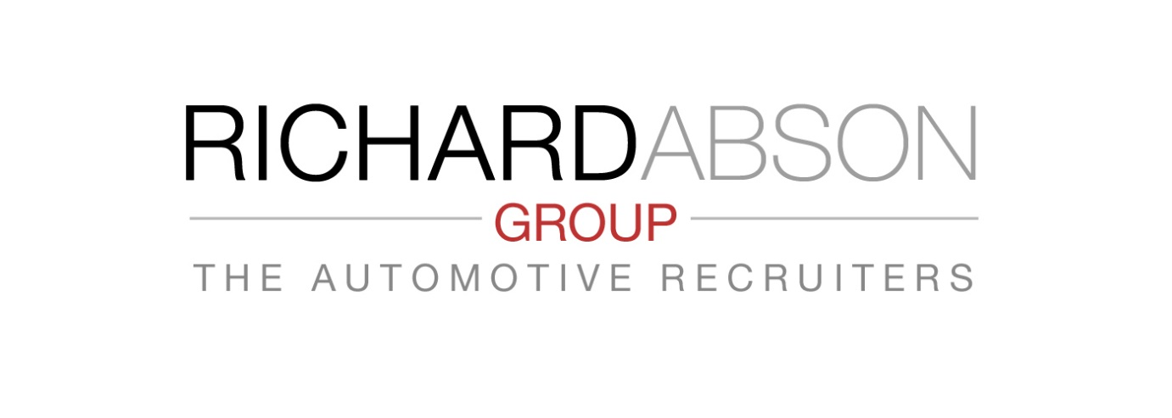Key Elements of a Thorough Recruiting Process
Part 2 – Interview Process.
As you operate a structured Sales Process to ensure maximum conversion rates, so should you operate a structured Interview Process designed to end only with a mutual best fit of candidate and employer needs.
Some essential pointers : Never make an offer of employment on just One interview. (One does not marry after a single date!).
Both parties need to meet 2 or 3 times or more, depending upon seniority of appointment. Resist making an appointment offer if the ‘best’ of your candidates does not ‘tick your boxes’ sufficiently. It is better to search again, or engage alternative sources of candidates.
The interview process is a 2-way process in which both employer and right candidate have a full opportunity to make a judged decision, in the mutual interests of a long term relationship.
‘Sell’ your company and opportunity to candidates. Consider ‘why a successful candidate should work for you and your company?’ Too many employers just judge candidates and possibly assume the candidate knows all about you - but often does not.
The Process :
1st Meeting – Should only be a max 60 minute ‘Compatibility’ appraisal for each party – a chance to cover overview of the Candidate and a possible fit; The Job and content; Selling your Company & Opportunity... After which, both parties can go away and consider; and work to a 2nd short listed meeting.
2nd Meeting - From a short listing, you may feel that the candidate potentially has what you need. This
meeting involves drilling down into detail, all aspects needed to make the next decision. Allow full opportunity for candidates to ask any questions. Always be prepared to substantiate with evidence, any job or employment terms, objectives and conditions – you want candidates to have ‘ownership’ of their decision.
3rd Meeting (and subsequent) – Probably for the Final Candidate to whom an offer is expected. If not covered in 2nd – An opportunity to clear any ‘grey areas’; to cross Ts and dot I’s. Allow the candidate to meet all the significant people he/she will be working with! It is always better to agree final deals & terms Face 2 Face, and shake hands. An offer letter is then just formal confirmation!

Other Considerations
• You must carry out due diligence on appointees, with reference checks etc.
• Make use of Assessment Programmes and Personality Profiling where appropriate.
• At later interview stages, invite other management peers to interview and assess with you.
• Test candidates’ commitment to join you regularly during the process, and prior to offer.
• Make a decision ONLY if it is RIGHT.

The Automotive Recruiters Tel : 01829 730116 Email : info@the-amr.com

